SIMATS ENGINEERING
NAME: A.Preetika Sudhakar
RREG NO. 192371073
COURSE NAME: Database Management Systems
COURSE CODE: CSA0501

Ex. No.: 11 Date:
AIM:
DATABASE WITH AUTO_INCREMENT SEQUENCES
To create Auto Increment sequence on the given relation.
DESCRIPTION:
SEQUENCE:
In MySQL, a sequence is a list of integers generated in the ascending order i.e., 1,2,3… Many applications need sequences to generate unique numbers mainly for identification e.g., customer ID in CRM, employee numbers in HR, equipment numbers in services management system, etc.
To create a sequence in MySQL automatically, you set the AUTO_INCREMENT attribute to a column, which typically is a primary key column.

;
SYNTAX:
CREATE TABLEtable_name(
col_name1AUTO_INCREMENT PRIMARYKEY, col_name2, col_name3, ….);
Questions:
1. Populate register number using auto increment in DBMS_Stud table.
2. Manually populate register number
3. Drop the auto increment
1.ANSWER
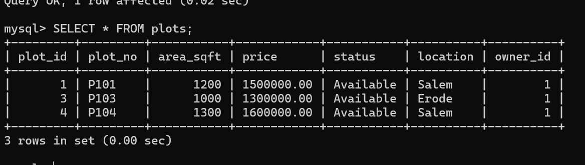

2.ANSWER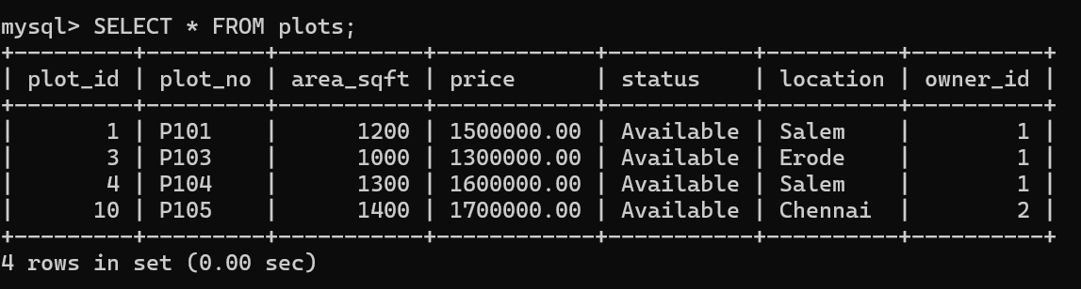
3.ANSWER
